# 

# 

# Bahria University,

# Karachi Campus

Course: SEN-311 – Software Construction Term: Fall 2022, Class: BSE- 5(B)

Submitted By:

Abdul Quddos 69984

(Name) (Reg. No.)

Submitted To:

Engr. Misbah Parveen / Engr. Ayesha Khan

Signed Remarks: Score:

INDEX

|  |  |  |  |  |
| --- | --- | --- | --- | --- |
| SNO | DATE | LAB NO | LAB OBJECTIVE | SIGN |
| 01 | 30/09/2022 | 01 | Design to code |  |
| 02 | 07/10/2022 | 02 | Recursion |  |
|  |  |  |  |  |
|  |  |  |  |  |
|  |  |  |  |  |
|  |  |  |  |  |
|  |  |  |  |  |
|  |  |  |  |  |
|  |  |  |  |  |
|  |  |  |  |  |
|  |  |  |  |  |
|  |  |  |  |  |
|  |  |  |  |  |
|  |  |  |  |  |
|  |  |  |  |  |
|  |  |  |  |  |
|  |  |  |  |  |
|  |  |  |  |  |
|  |  |  |  |  |
|  |  |  |  |  |

# Bahria University,

# Karachi Campus



LAB EXPERIMENT NO.

1

LIST OF TASKS

|  |  |
| --- | --- |
| **TASK NO** | **OBJECTIVE** |
| **1** | Create a class diagram of Banking System and generate code in visual studio |
|  |  |

Submitted On:

18/10/2022

(Date: DD/MM/YY

**Task # 01: Create a class diagram of Banking System and generate code in visual studio**

Solution:

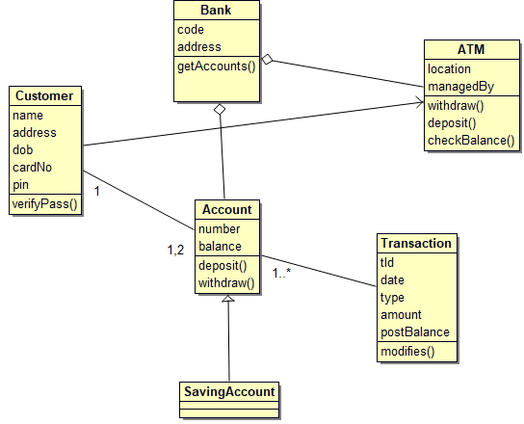

class Account extends CheckingAccount {

public int number;

public int balance;

public deposit() {

}

public withdraw() {

}

public Bank ;

public Customer ;

public Transaction ;

public SavingAccount ;

}

class ATM {

public Bank ;

public String location;

public String managedBy;

public void withdraw() {

}

public void deposit() {

}

public void checkBalance() {

}

}

class Bank {

public ATM ;

public String code;

public String address;

public void getAccounts() {

${body}}

}

public Account ;

}

class Customer {

public String name;

public String address;

public String dob;

public int cardNo;

public int pin;

public verifyPass() {

}

public ATM ;

public Account[] ;

}

class SavingAccount extends Account {

public Account ;

}

class Transaction {

public String tId;

public int date;

public String type;

public int amount;

public int postBalance;

public modifies() {

}

public <Account> ;

}